Q1.Explain break statement in java programming?

Ans: if we want to exit from the loop or switch then we should go for break

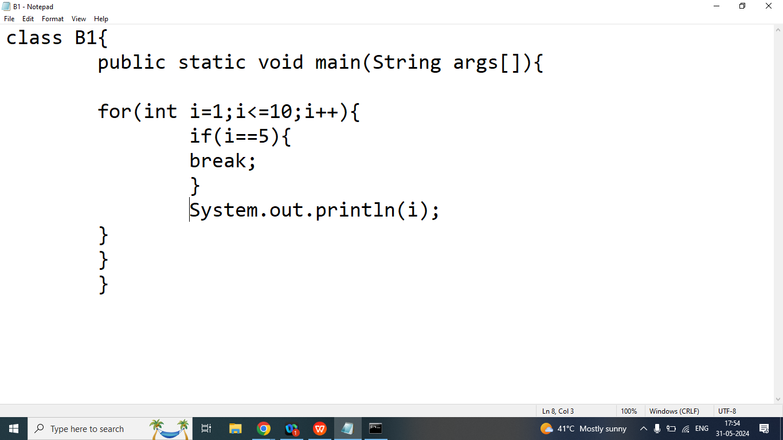

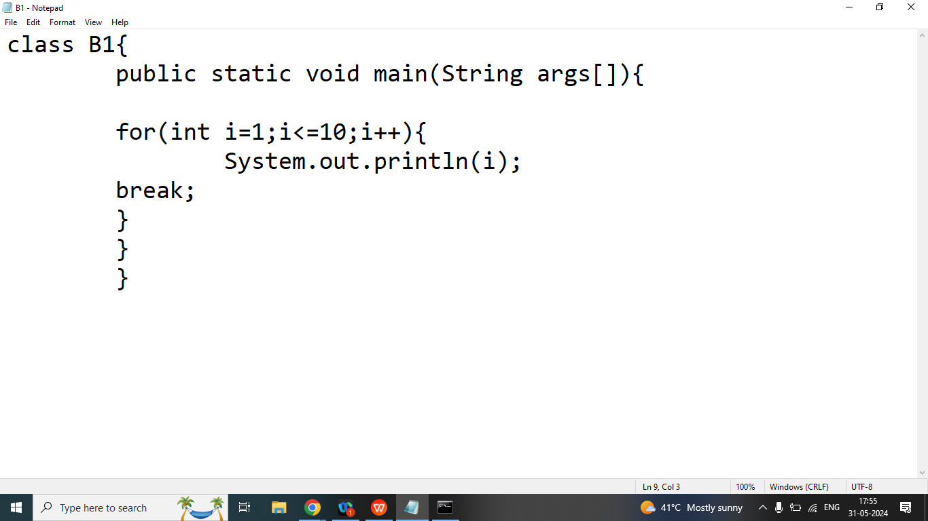

Q2. Explain continue statement in java programming?

Ans: if we want to exit from the current iteration then we should go for continue statement.

continue statement only work with loop.

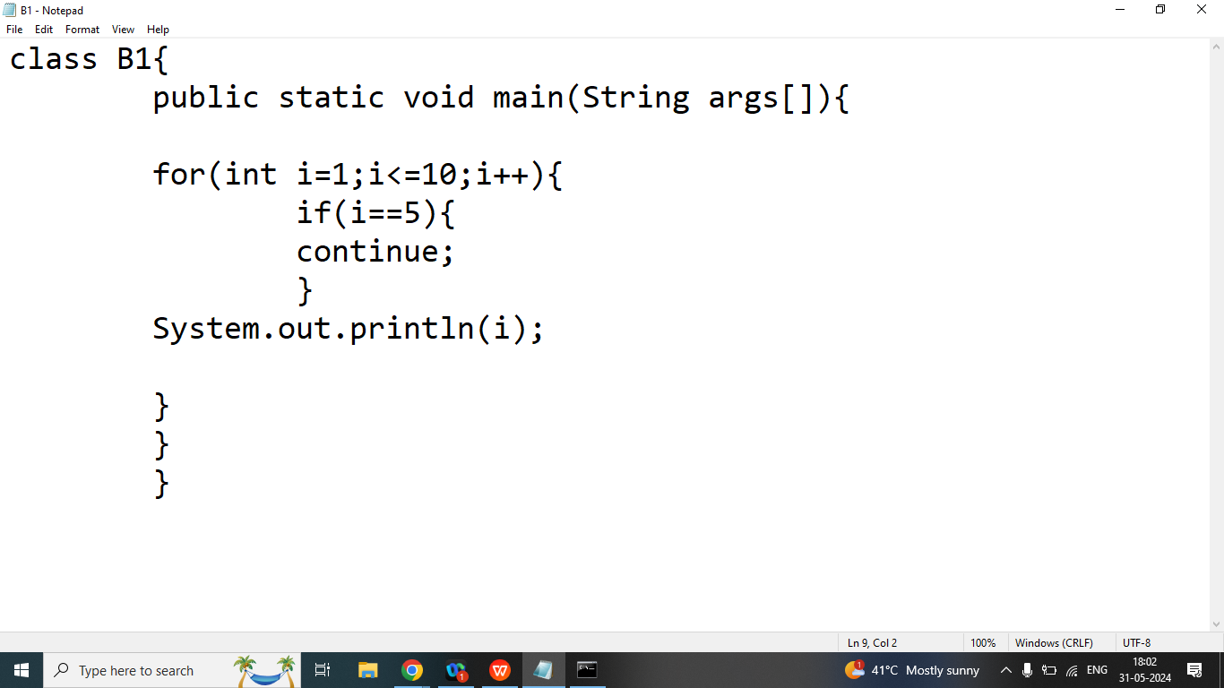

class A1{

public static boolean isPrime(int n){

int count=0;

for(int i=1;i<=n;i++){

if(n%i==0){

count++;

}

}

if(count==2){

return true;

}

else{

return false;

}

}

public static void main(String args[]){

int n=10;

int countp=0;

for(int i=1;i<=n;i++){

if(isPrime(i)){

countp++;//

}

}

System.out.println(countp);

}

}